Student’s name | …………………………………………………….…… | Grade | 5
Subject | Computer | Week No. | 13
Lesson Title | Flowcharts | Unit
Worksheet No. ( 13 )

Question A: Fill in the blanks with the words in the box below.

Data | Decision | Process | Terminator
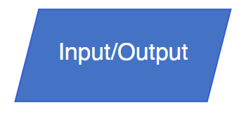



Good Luck

